Greater Lawndale Healthy Work Emerging Themes
12 Focus Groups
Revised 02/11/18

Purpose of Focus Groups: To engage residents in a facilitated discussion around a set of questions to explore how work is experienced in the community and how it impacts community health in order to identify community-level interventions to promote healthy work.

Research Questions: How to residents in the Greater Lawndale area experience work? How do the experiences of work of residents impact health at the community level?

Findings

Overall focus group participants emphasized the importance of decent work to promote health in Greater Lawndale and described that residents’ negative experiences with seeking, getting, keeping or dealing issues at work impact their relationships, families and the community as a whole. Three main themes emerged. Text in italics are from focus group participants themselves.

- Systematic Marginalization from the Pathways TO Decent Work Situations
- Contextual, Structural Hostility to SUSTAIN Healthy Work; and,
- Violations in the Rights, Agency and Autonomy of Resident Workers

Cutting across these three themes residents described that workers can internalize or embody these stressful experiences producing additional physical and mental health consequences. Also with so many people in the neighborhood facing the same challenges social norms are established that normalize unjust experiences.

Community Members Experience Systematic Marginalization From Pathways TO Decent Work Situations

Focus group participants described obstacles to securing decent work for community members that are structural and systemic. There are problems larger than [Greater Lawndale] that are robbing residents of jobs. Residents face discrimination in identifying jobs, needing to rely on word of mouth from family and friends, and also face discriminatory hiring practices by documentation status, language, criminal record history, age, gender and race/ethnicity. Its Racism…lets be real. Relying on one’s social network for work is key (you have to know somebody to get in) but thiss leads to a common kind of work that is low wage, high risk and unstable.
- Lack of community resources to prepare residents for work are the result of systems of oppression that result in economic and social disinvestment in Greater Lawndale.
  - Lack of investment in and poor quality public education results in less skilled, prepared workers
  - Some very good community resources but they are insufficient community/few good job training opportunities in the community
  - Few healthy work mentors/apprentice opportunities as most people are engaged in precarious work
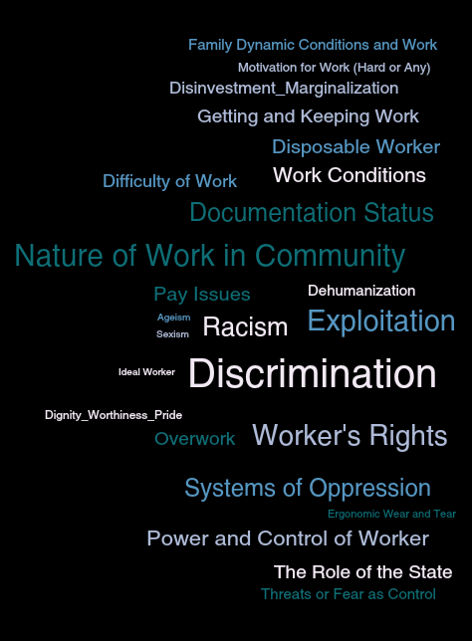
- An inherent community-level disadvantage exists with community contextual barriers to decent work: lack of affordable, quality child care (familial resources are already strained), limited affordable, reliable transportation (workers are exploited by employer transportation options), concerns for safety in getting to and from work restrict options for some work, job type availability (most work at the community level is precarious in nature), few good jobs in neighborhood (disinvested employers many whom live outside of neighborhood, go back to their mansions in the suburbs, and won’t hire residents). There is just not the economic development [in Greater Lawndale] that is needed.

Contextual, Structural Hostility to SUSTAIN Decent Work

Once secured, residents experience hostile work conditions that threaten job security. Contextual challenges are seen in the nature of work, and conditions at work, as well as the exploitive power of the employer.

- The nature of work described was precarious in the unpredictable hours, unknown terms, low wage and long hours. Low wage, poor terms require more work and restrict consumption potential and family/leisure time.
- Work conditions were described as difficult, hard labor, repetitive with insufficient information and protective gear.
- Challenges due to the exploitive power of the employer include overt sexual, racial/ethnic, language and documentation status discrimination as well as a culture that prioritizes profits over people relying on a disposable workforce (someone else is waiting in line for this job) that doesn’t need training or protection of rights. Some described no control at work in terms of safety, access to food and drink and use bathroom as extreme exploitation that is not uncommon.
- Some community issues also threaten job stability, for example fear and concerns for safety traveling to jobs due to community crime, and police harassment.

Violations in the Rights, Agency and Autonomy of Resident Workers

Unanimously focus group participants agreed that workers overall do not know their rights. However, participants questioned the relevance of knowing one’s rights if a) your human rights are already being violated b) you are not able to exercise them without risking your job. Employers deliberately keep workers in the dark so as to keep them powerless. Employers face no consequences to their exploitation since it leads to profits. Dehumanizing types of work and work conditions or treatment at work were described compromising one’s self-respect but tolerated on behalf of the family. Nothing’s going to change…so I think it’s about just getting used to it even though it is not right. Risk for exploitation prohibits self advocacy. Decent work as a human right brings dignity, satisfaction pride. When barriers are in place to decent work there are individual, family and community health consequences. Dehumanizing work leads workers to think that they are paid pennies so they must deserve pennies.

Power is central to experiencing work exploitation. The power of the employer to exploit is great as is the power of the system to oppress and create barriers. These are structural issues but with a very personal affect –[we both] struggle with [this] and feel powerless against [it].

CROSS-CUTTING THEME: Strained Social Resources as a Consequence of Inequities

Across the three themes, the issue of stress on the individual and his/her social networks emerged as a consequence of the inequities residents’ experience. The inability to get ahead despite excessive effort was exhausting and defeating. Impacts were described on one’s physical health both in terms of hard labor since there are few options but to take difficult work (aqui todos trabajamos) but also since one must ignore health due to lack of resources (health insurance) and time (can’t take off work or risk losing work) to care for oneself. Feels like you are running on a hamster wheel and you are sprinting and not getting anywhere. Work-related stress results in family strain with workers either projecting frustration on family or deliberately keeping stressors from family to protect them (bottling up). You can give every bit of yourself every single day and still not come out ahead. Excessive barriers to work and poor work conditions make informal, illicit work an option.

Workers are influenced by community contextual issues to stay in precarious work situations due to devotion to family and due to social norms of unfair work. This creates chronic strain on community level. Participants described that the pathways to decent work are too fraught and rare opportunities for decent work were insufficient and not the norm and are perceived as not for me and are avoided. Strong social bonds between residents engaged in exploitive work situations serve to build resilience but the common referents in the neighborhood may also set lower expectations and reducing opportunities for group action against the exploitation. Social cohesion and capital are useful for getting and keeping jobs but may also hold residents back from speaking out against injustices. Disrupting systematic barriers to decent work and creating good jobs for all while building resiliency and solidarity among residents were described critical actions to promote health in Greater Lawndale.

